REQUEST SERVICES
@startuml

actor Student
participant UI
participant "Auth Service" as AuthService
participant Database
participant "Request Service" as RequestService

‘Register to service
Student -> UI: Register/Login
UI -> AuthService: sendCredentials()
AuthService -> Database: validateUser()
Database --> AuthService: confirm
AuthService --> UI: loginSuccess()

‘Send request
Student -> UI: Fill Request Form
UI -> RequestService: submitRequest(data)
RequestService -> Database: saveRequest()
Database --> RequestService: saved
RequestService --> UI: success
UI --> Student: Show Confirmation

@enduml

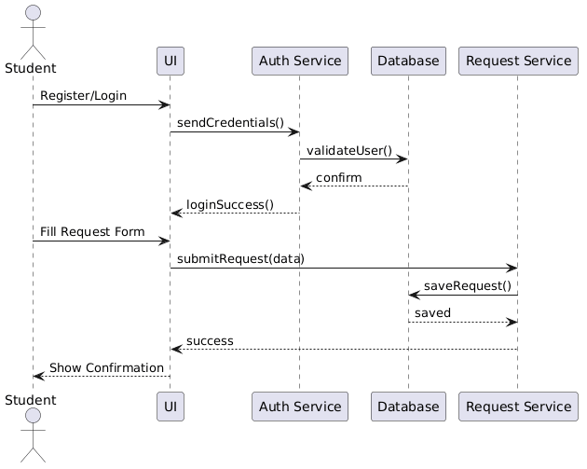

UPDATE STATUS

@startuml

actor "Admin/System" as Admin
actor Student
participant "Request Service" as RequestService
participant Database
participant "Notification Service" as NotificationService
participant "Email Service" as EmailService

'Update request
Admin -> RequestService: updateStatus(requestId, status)
RequestService -> Database: updateStatus()
Database --> RequestService: updated

'Confirm notification status
RequestService -> NotificationService: notifyStatusChange()
NotificationService -> Database: checkUserPreferences()
Database --> NotificationService: preferences

alt Notifications Enabled
NotificationService -> EmailService: sendEmail()
EmailService --> Student: Email Notification
else Notifications Disabled
NotificationService -> NotificationService: Do nothing
end

@enduml

